INSTRUCTIONS FOR FITTING A HOLDEN SPORTS STEERING WHEEL

PART 1 REMOVAL OF WHEEL

- Turn the steering wheel so that the vehicles wheels are pointing straight ahead.

- Turn the Ignition OFF and remove the key from the Ignition. DO NOT put the key back in the ignition until instructed to do so.

- Disconnect the negative battery cable from the battery.

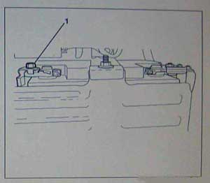

3a: Remove the cargo area centre carpet.

3b: Remove the left hand cargo area carpet side.

3c: Clean any existing corrosion from the battery terminal
and the battery negative cable end.

3d: Remove the battery negative cable to battery terminal
retaining nut (1).

3e: Remove the negative battery cable from the terminal
and place it away from the battery.

- Wait 2 minutes before removing the 10 Amp Airbag Fuse (1) labeled F1.

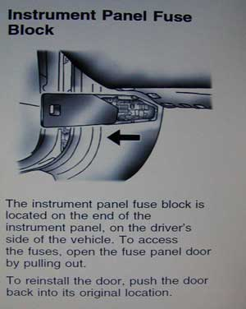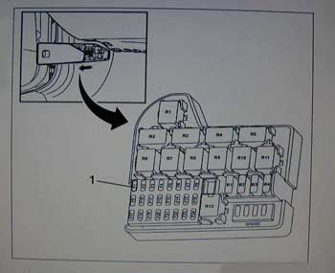

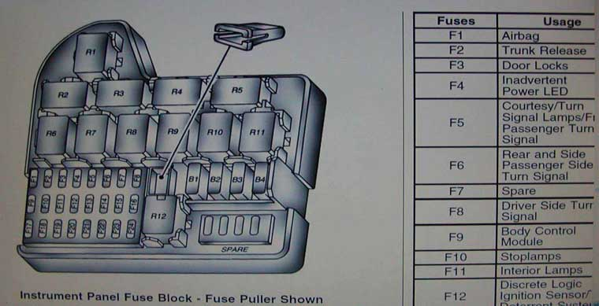

- Wait 2 further minutes before working on the Airbag System.
6a: Release the steering column tilt lever.

6b: Fully lower the steering wheel and column assembly.

IMPORTANT
Do not use excessive force to separate the steering column trim covers.

6c: Press the steering column upper trim cover lower edge towards the front of the vehicle and lift in order to disengage the front locking tabs (4).

6d: Unclip the face of the steering column upper trim cover (1) from the steering column lower trim cover (2).

6e: Lift the steering column upper trim cover face and pull towards the rear of the vehicle in order to disengage the rear locking tabs (3).

6f: Remove the steering column upper trim cover (1).

6g: Remove the steering column lower trim cover to steering column assembly retaining screw (3).

6h: Pull the steering column lower trim cover (2) towards the rear of the vehicle in order to disengage the mounting tabs.

6i: Remove the steering column lower trim cover.

- Remove the steering column trim covers

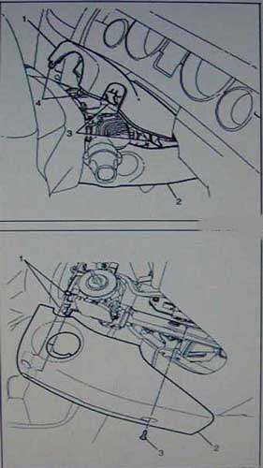
- Remove the Steering Wheel Air Bag Module.

7a: Rotate the Steering Wheel 90 Degrees from the straight ahead position to expose an aperture hole in the top rear of the Steering Wheel Hub.

VIEWED FROM THE REAR OF THE STEERING WHEEL.

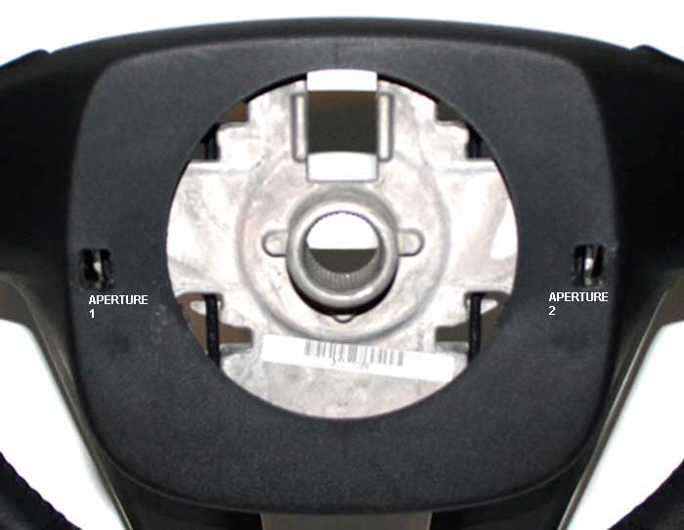

7b: Using a tool such as a medium to large flat blade screwdriver, insert into the APERTURE and in between the exposed aluminium casting and the round section black spring clip. Pivot or rotate the screwdriver to push the black spring clip upwards , away from the centre of the steering wheel.

This will relieve the tension on the spring loaded retaining clips. One side of the Airbag Module will move slightly away from the Steering Wheel.

7c: Rotate the Steering Wheel 180 Degrees to expose the remaining access aperture hole. Repeat the same Pivot and Rotate action with the screwdriver in the 2nd Aperture to release the remaining spring loaded retaining clip. Be prepared to catch and support the Airbag Module as it pops free of it’s final retaining latch.

(Try supporting the weight of the airbag, or wriggling the airbag gently while twisting the screwdriver in the Aperture if you are having difficulty releasing the big black spring clip.)

THIS VIEW WITH THE REAR HUB REMOVED SHOWS WHAT YOU ARE TRYING TO ACHIEVE

IN STEP 7. THE TOOL IS SHOWN IN PLACE WHERE THE APERTURE HOLE NORMALLY IS.

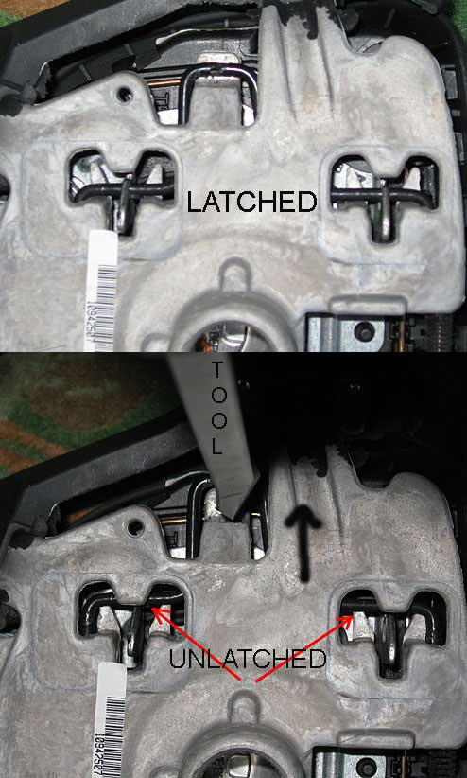

8: Carefully lift the Airbag Module slightly away from the steering wheel and disconnect the wiring harness connectors (Orange and Blue) from the rear assembly.

9: Disconnect the large black earth connector.

8a: Using a suitable tool press in on the locking tab (1) while lifting the connector (2) away from the Module.

9a: Remove the black earth connector from the bottom of the Airbag Module. (It just slides).
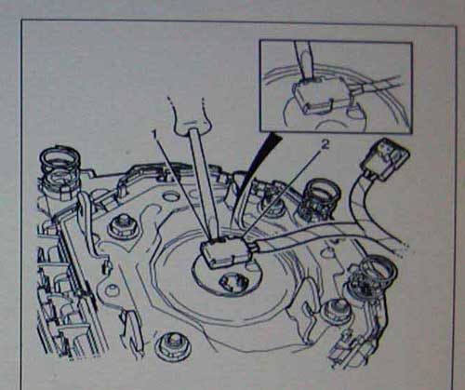

10: Carefully set the Airbag Module aside.

11: Disconnect the Steering Wheel Controls Electrical Connector (2).

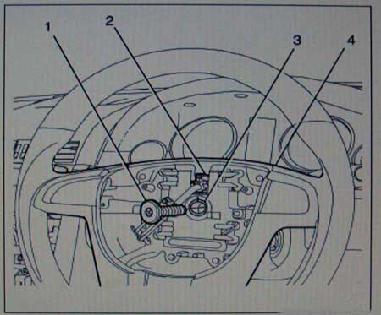

12: Remove the Steering Wheel to Steering Column retaining bolt (1). {previous picture}

For this you will need a Torx T50 socket.

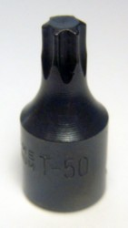

13: The steering wheel has a Master Spline so there is no real need to mark the wheel hub position against the steering column spline. The Steering Wheel can only go on the Column Spline in one position.

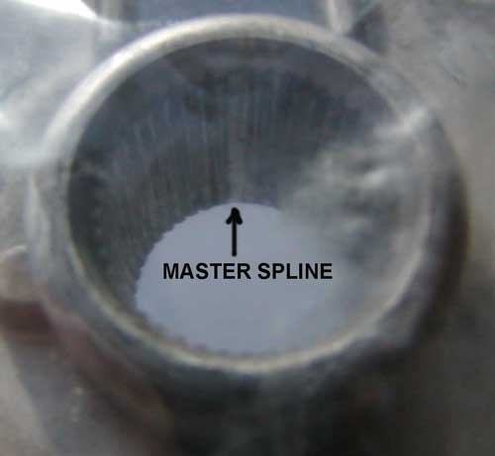

14: The front wheels and Steering Wheel must be in the straight ahead position before removing the Steering Wheel from the Steering Column Shaft.

15: Remove the Steering Wheel from the Steering Column Shaft.

16: From the front remove any screws holding the black hub onto the back of the steering wheel.

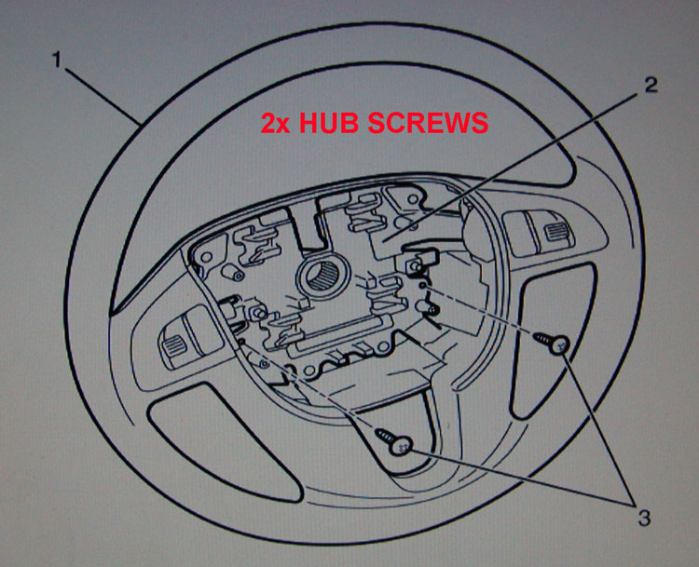

17: Turn the Steering wheel over, disengage the bottom locating lugs and pull the black hub towards you to remove it from the Steering wheel.

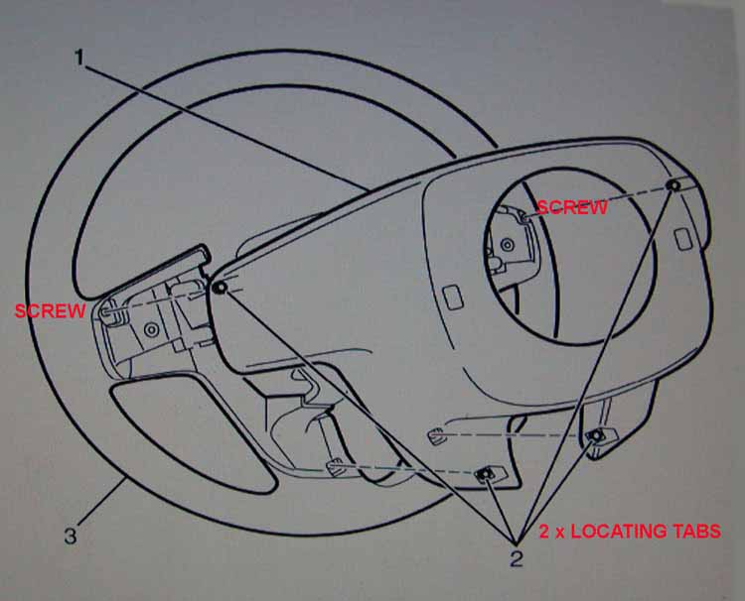

18: Working from the rear of the Steering Wheel use a Phillips Screwdriver to remove all the screws.

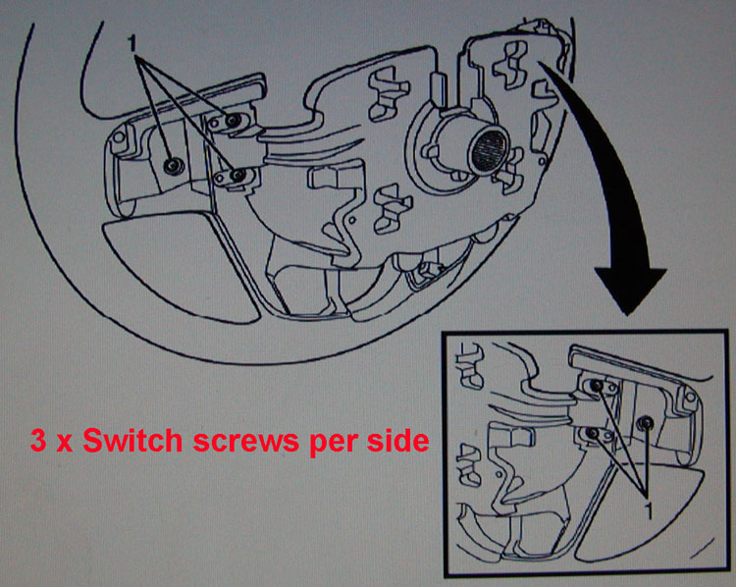

19: Flip the Steering Wheel over and working from the front, use a Phillips Screwdriver to remove the 2 screws which hold the silver trim in place.

20: Carefully remove the Silver Trim and Control Switches from the front of the Steering Wheel.

There are only 4 Large Screws that you should NOT REMOVE on the whole wheel assembly.
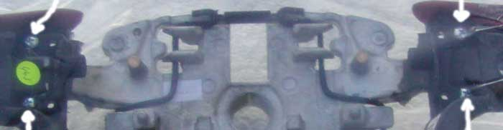

END OF REMOVAL INSTRUCTIONS.

